**ONLINE EMPLOYEE PAY ROLL MANAGEMENT SYSTEM**

**GROUP 11**

|  |  |  |
| --- | --- | --- |
| **S. No** | **Name** | **Roll No** |
| 1 | B. Manish Reddy | CB.EN.U4CSE17409 |
| 2 | E. Lakshmi Tejitha | CB.EN.U4CSE17417 |
| 3 | M. Sai Vinoothna | CB.EN.U4CSE17436 |
| 4 | P. Neeraj Kumar | CB.EN.U4CSE17445 |
| 5 | B Vindhya | CB.EN.U4CSE17467 |

**Tools Used:**

1. Xampp: For creating local host for database server.
2. MySQL Workbench: Database to store data.
3. Visual Studio Code: IDE for python flask.
4. HTML5 supported web browser.

**Abstract:** The main motive of this project is to develop a web-based application for managing all the activities that were done by a HR using python and flask. That includes adding an employee to database. Managing his data by using various database queries and calculating their monthly attendance with the help of csv/excel sheet and sending them their pay bills.

**Modules:**

* Login page for HR using his id and password.
* Adding employee.
* Add Attendance using excel sheet or csv file.
* Salary calculation. ( Excel sheet )
* Manage Employee. ( Update and Delete ).

**Here it follows the entire project.**

**Form 1** : This is the registration form for the human resource manager where he can create his login details. These details will be stored in MySQL workbench database and further used to login. In the database they will be stored in a database table named register.

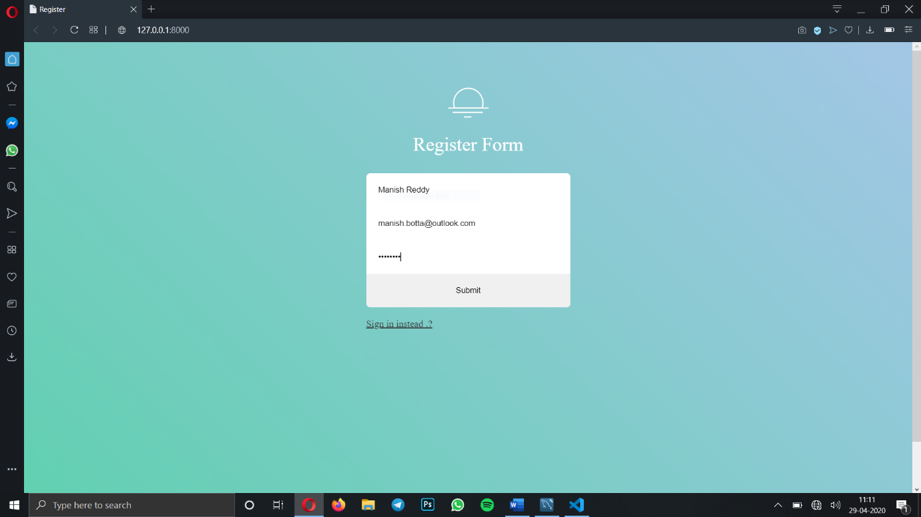

**Form 2 :** In the form 1 the HR has registered his login details. They are stored in the database as in the below picture in the register table. As highlighted in yellow.

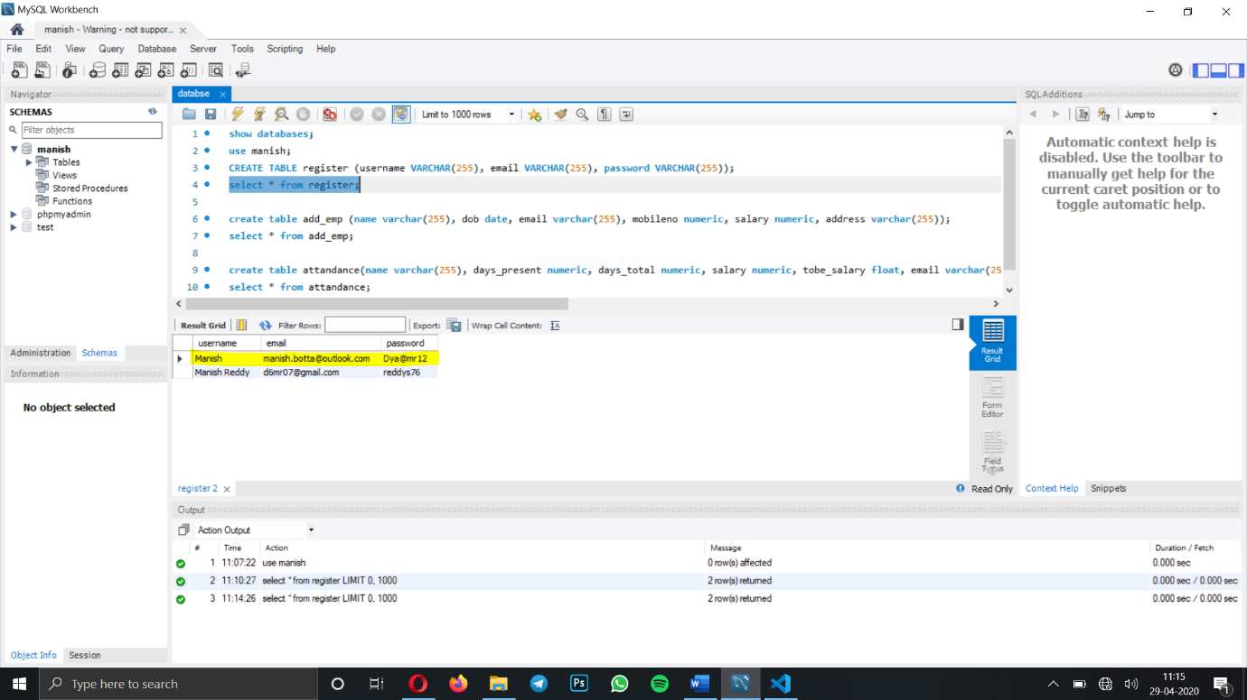

Here we enter the HR login details in order to carry out his operations.

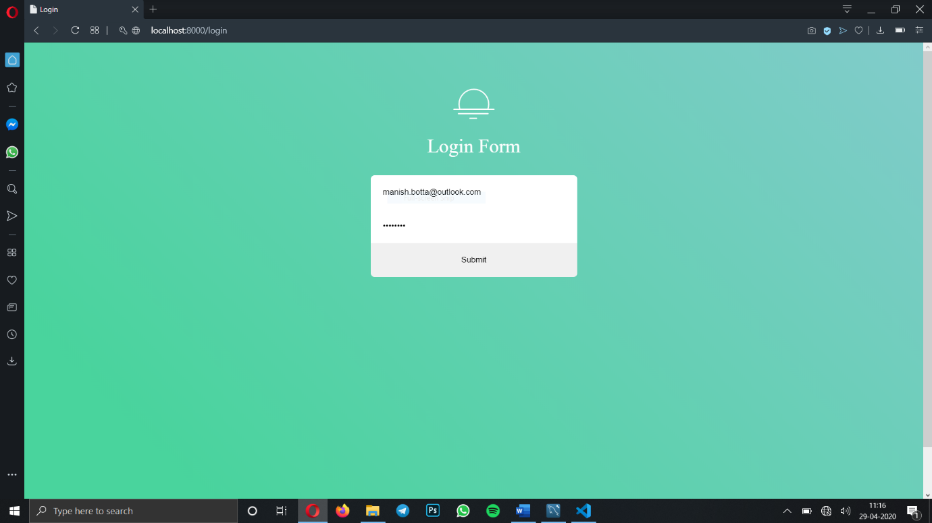

**Form 3** : After logging in this is the HR welcome page where he can choose his required actions from the below.

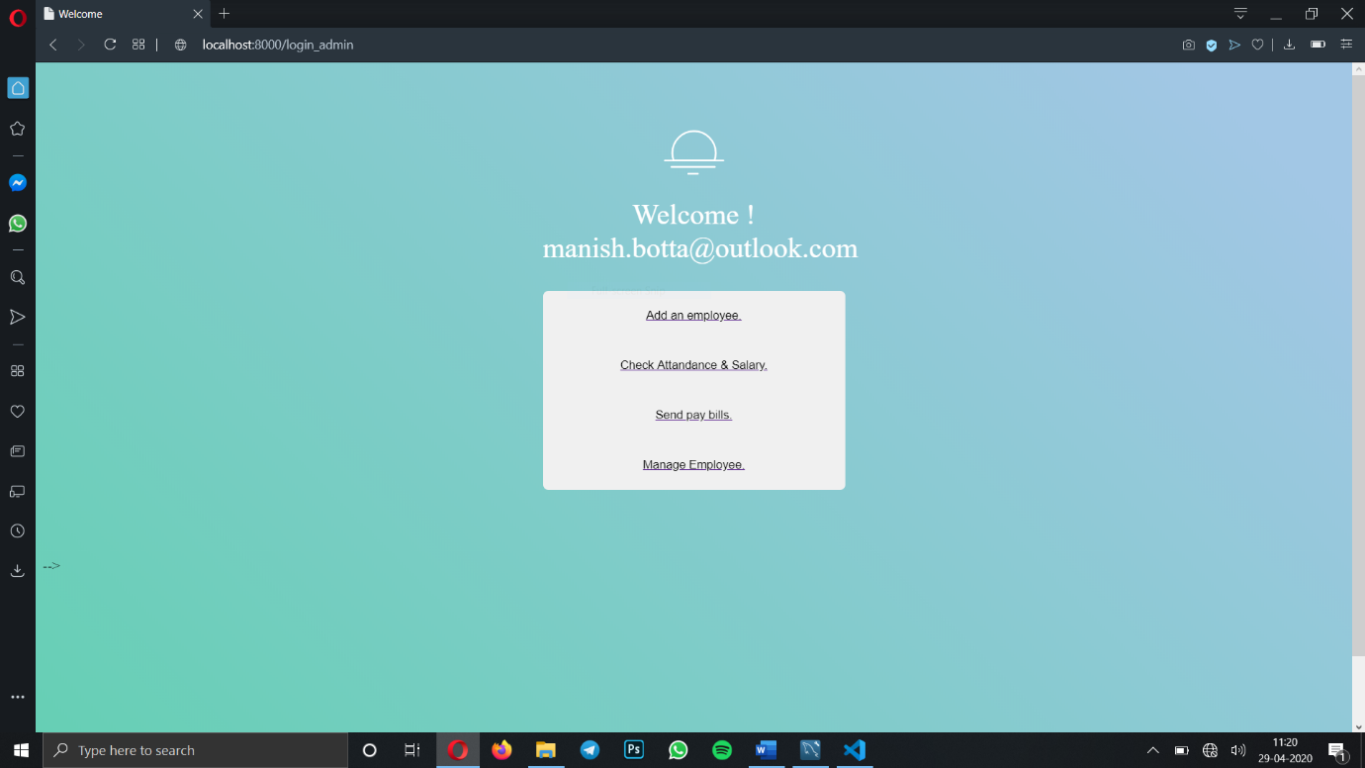

**Form 4** : This is the employee register form. Where a HR can add employees and those details will be passed into the database.

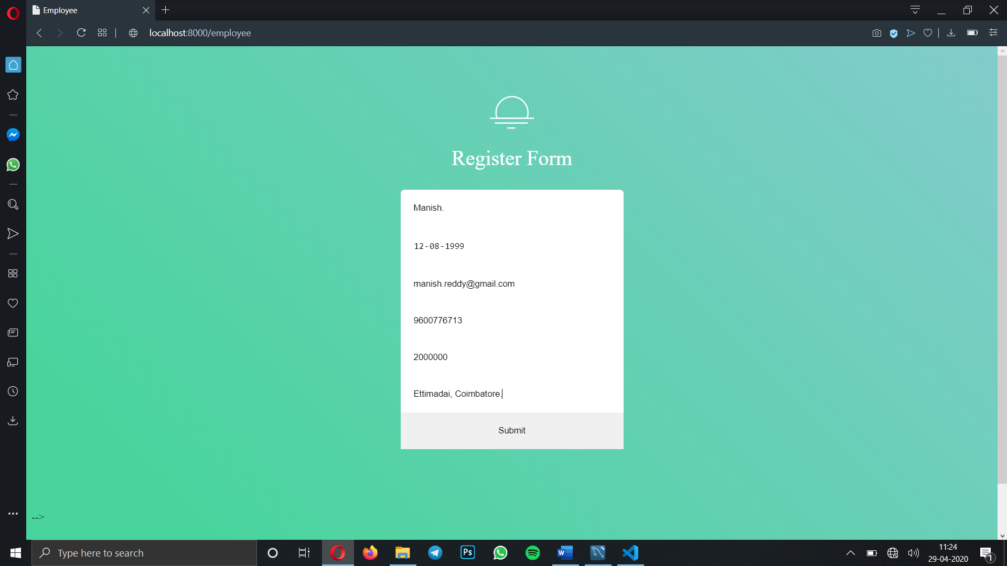

Here as so highlighted in the yellow colour the details entered through the form in the previous html page are stored in add_emp database table.

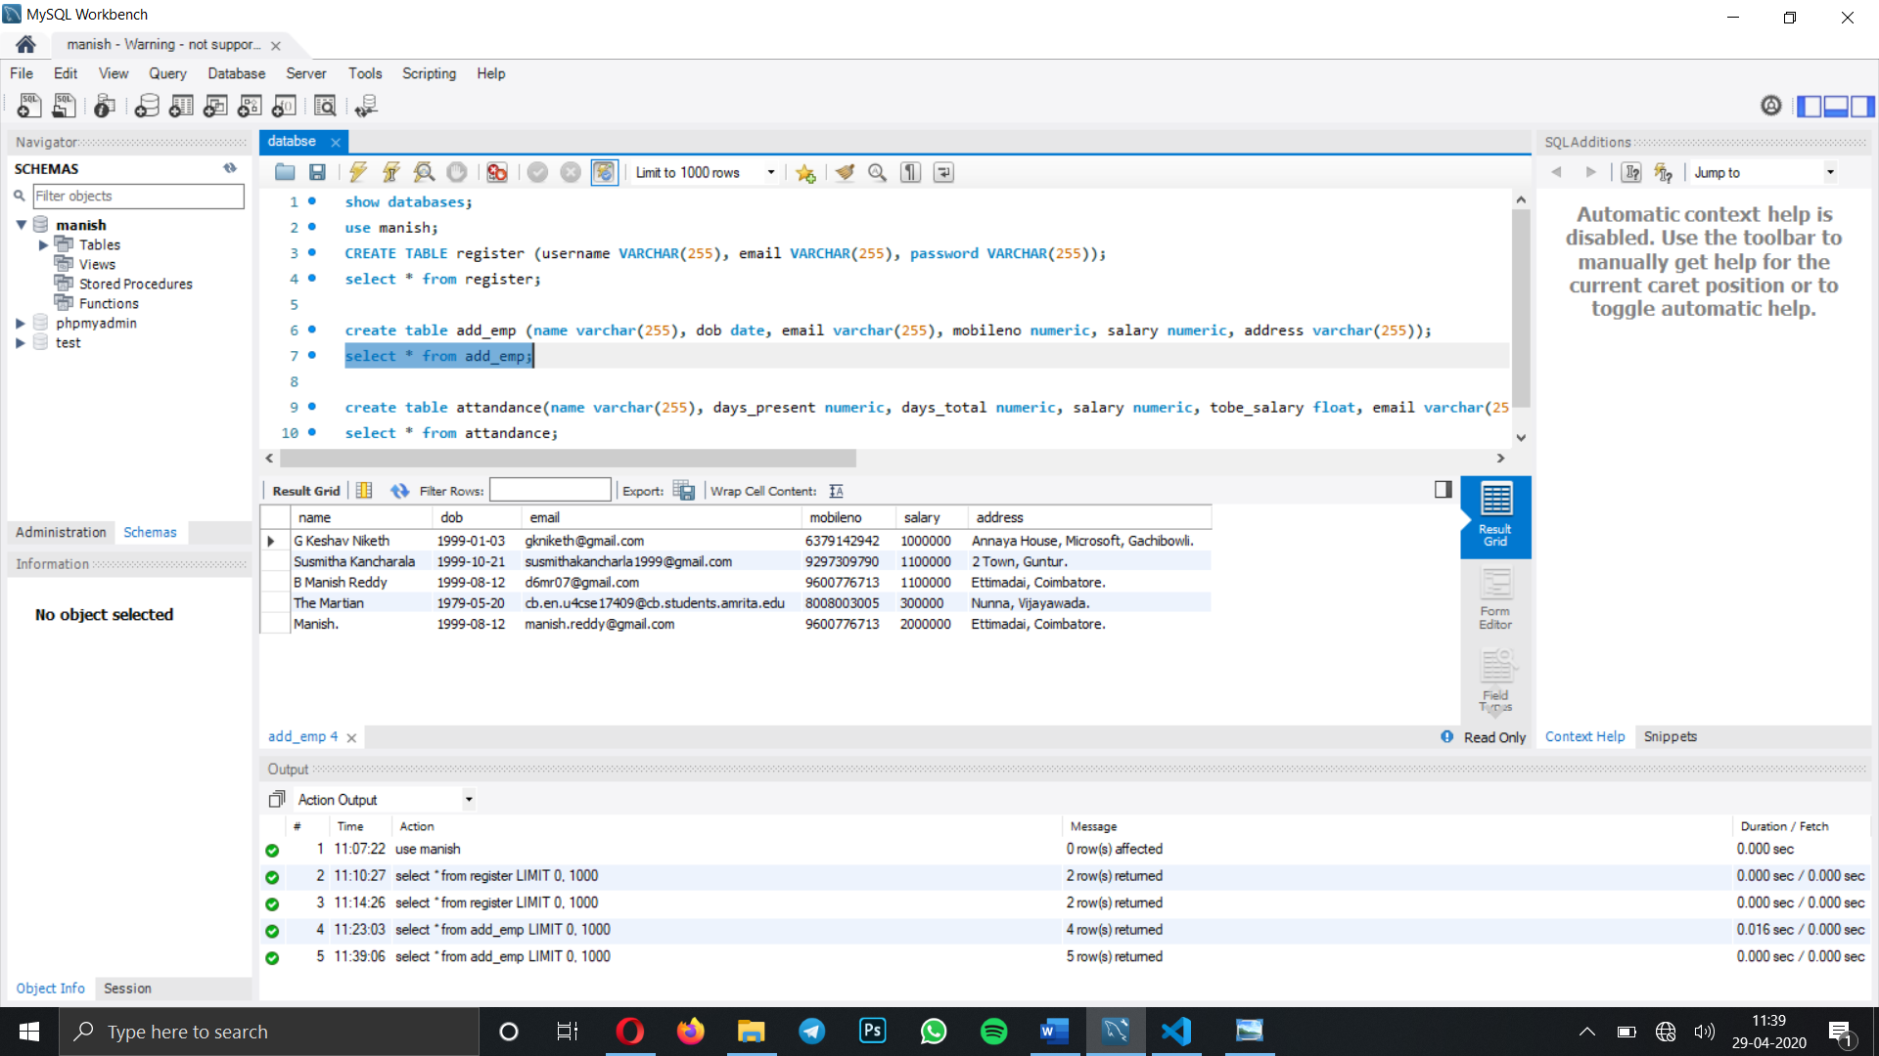

**Excel Sheet** : As of now for demonstration the following employees’ salary is calculated from the excel sheet with respective of their leaves per 30 days period month. They will be stored in data base.

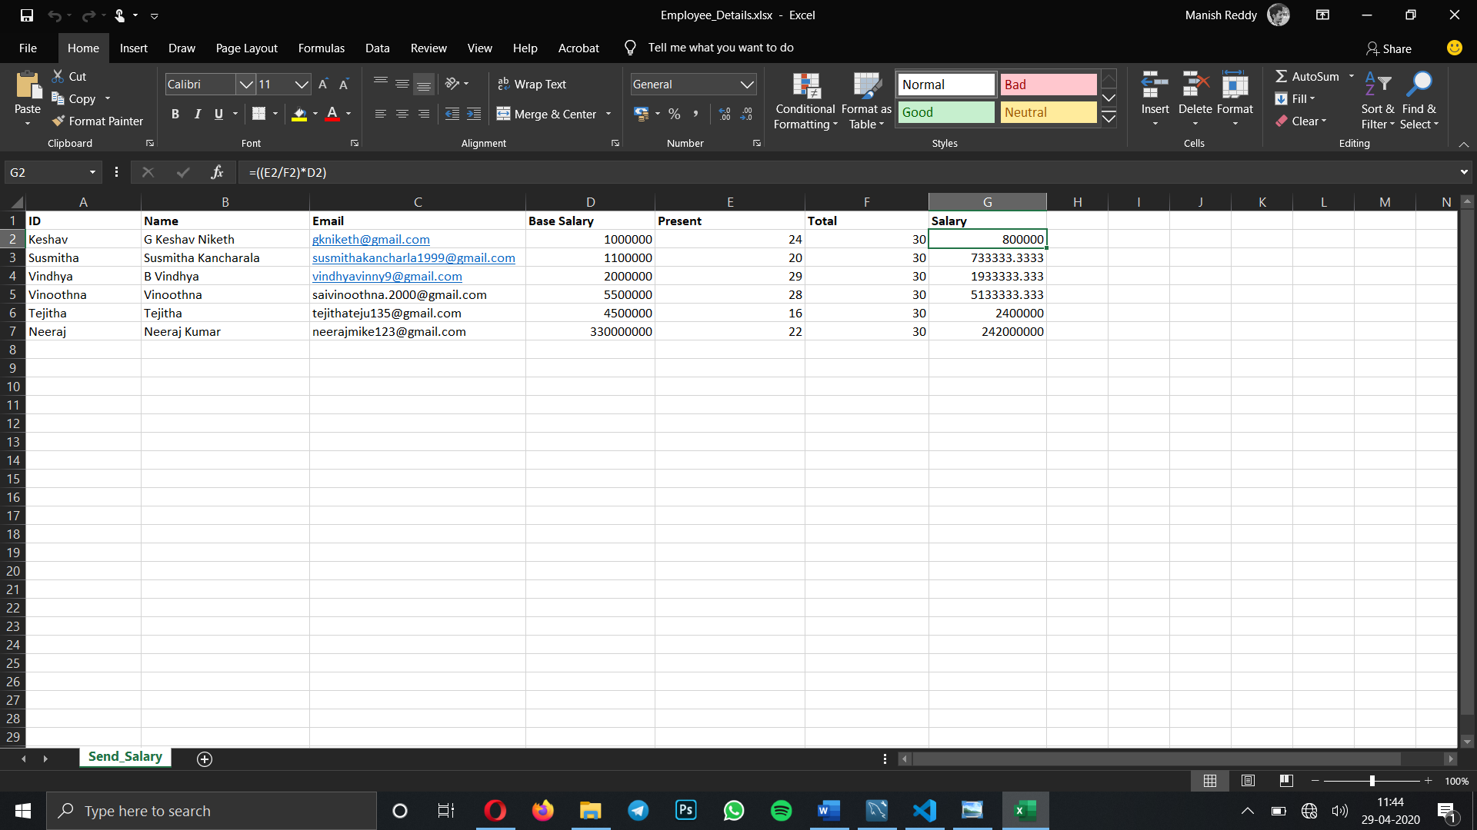

**Form 5** : Now we will go through module 2 where we fetch employee details and leaves he applied in a month with use of database queries and excel sheet.

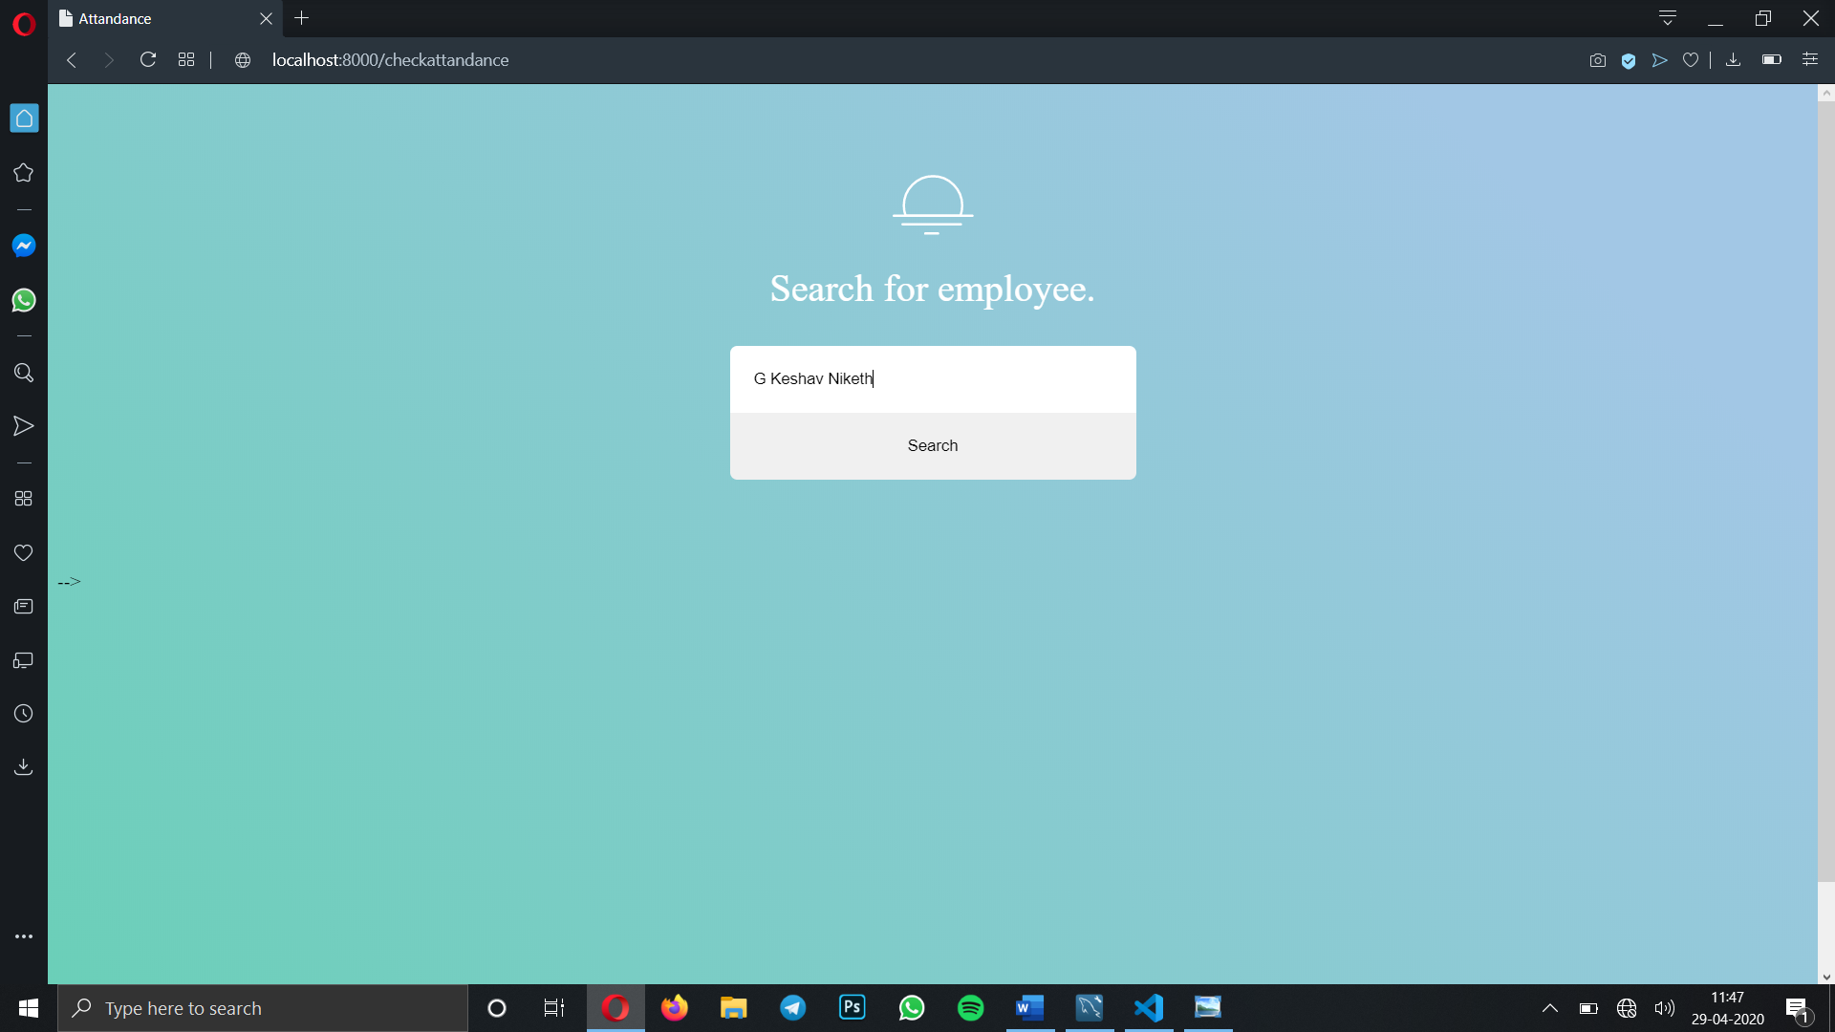

**Form 6** : From the previous step, the employee with name G Keshav Nikesh details are fetched and presented in the form of html tabular form. Out of which he worked for 24 days out of 30 total working days in a month. So out of his base salary 10,00,000 he has to be paid 80,000.

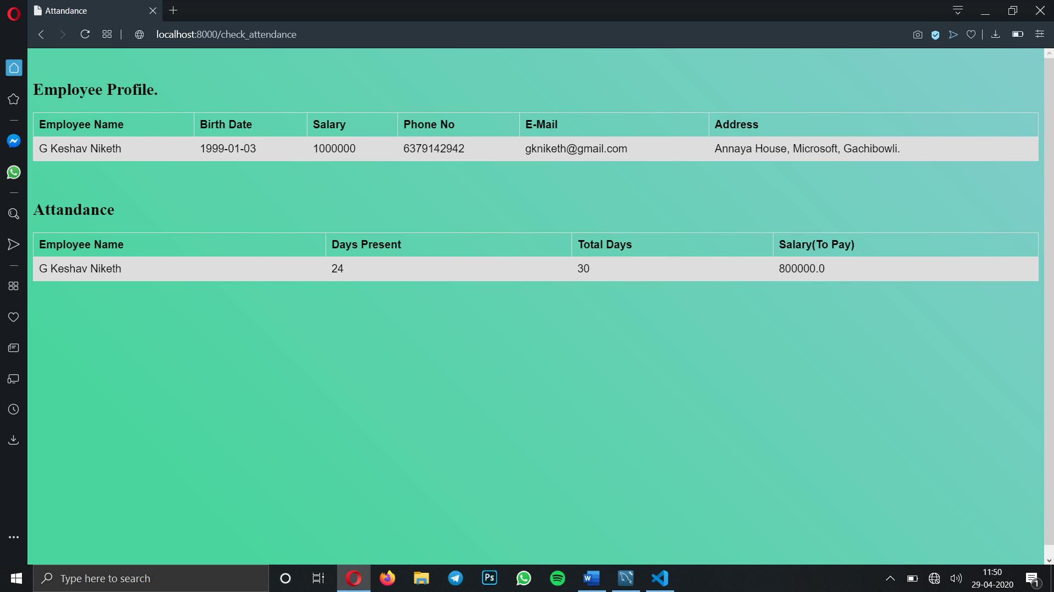

**Form 7** : Let’s go to next module. Managing the employee details where you have to choose which operation to perform either updating or deleting employee records from the company or the database.

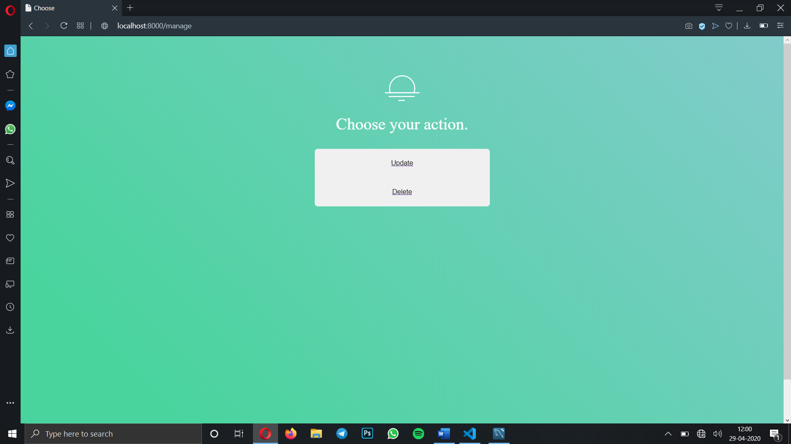

**Form 8** : In the update menu choose what you want to update like mobile no or salary or email address or address of the employee.

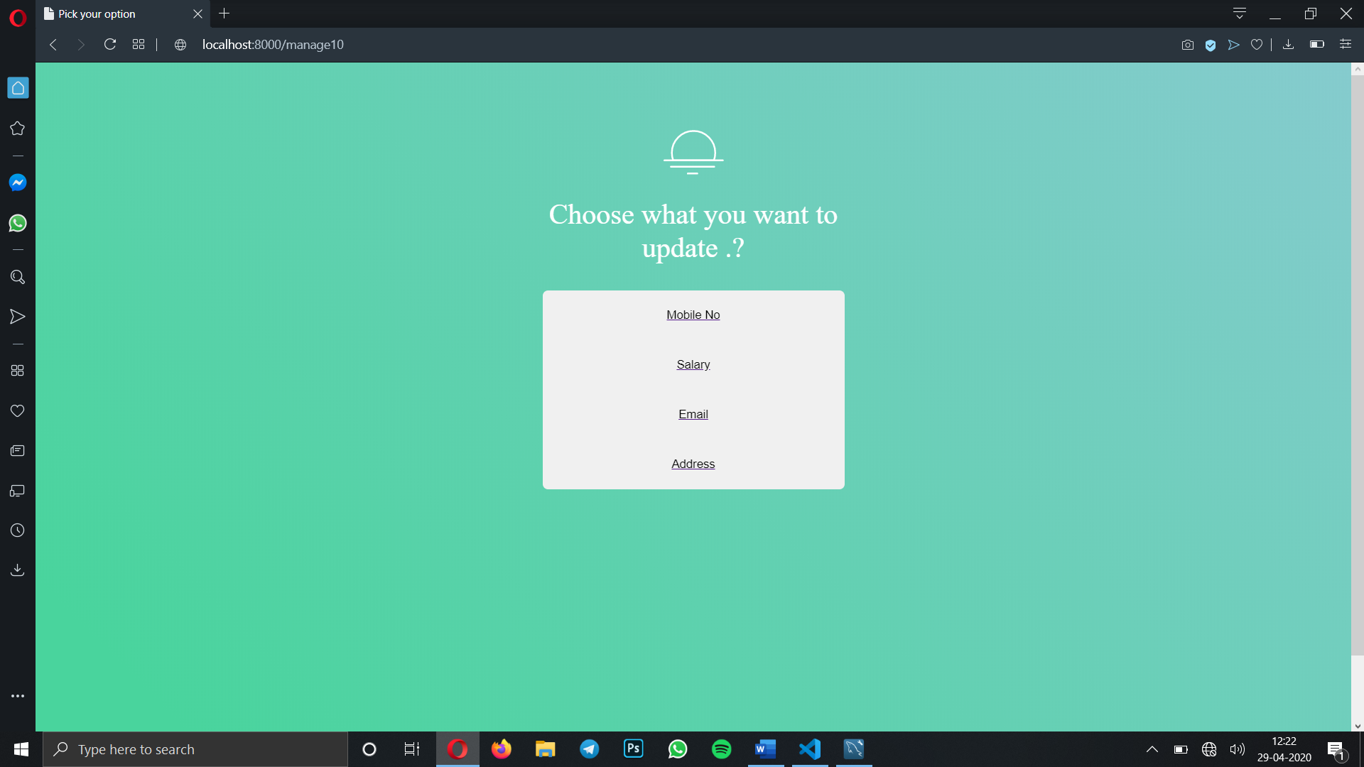

**Database** : Before getting started let’s see the database values of the employee that we are going to change. Here I choose employee B Manish Reddy for updating his details.

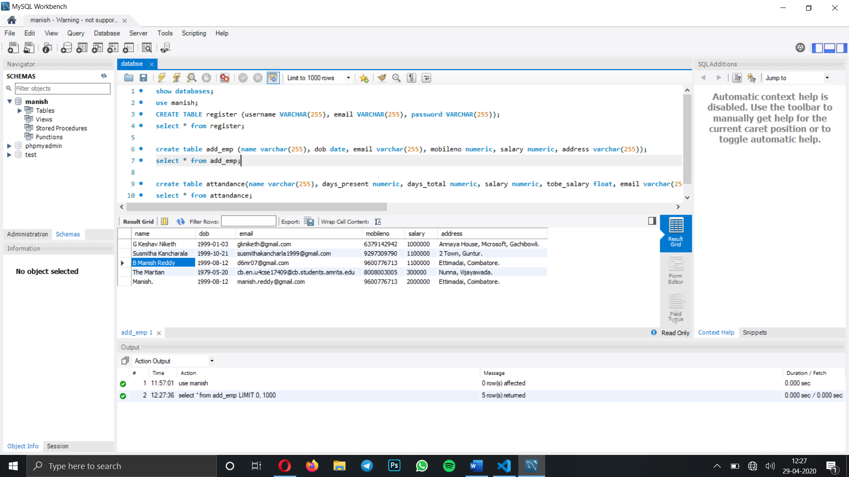

**Form 9** : From the above database I want to change mobile number of Employee B Manish Reddy from 9600776713 to 9441191606. Here I am entering employee name and phone number to be changed.

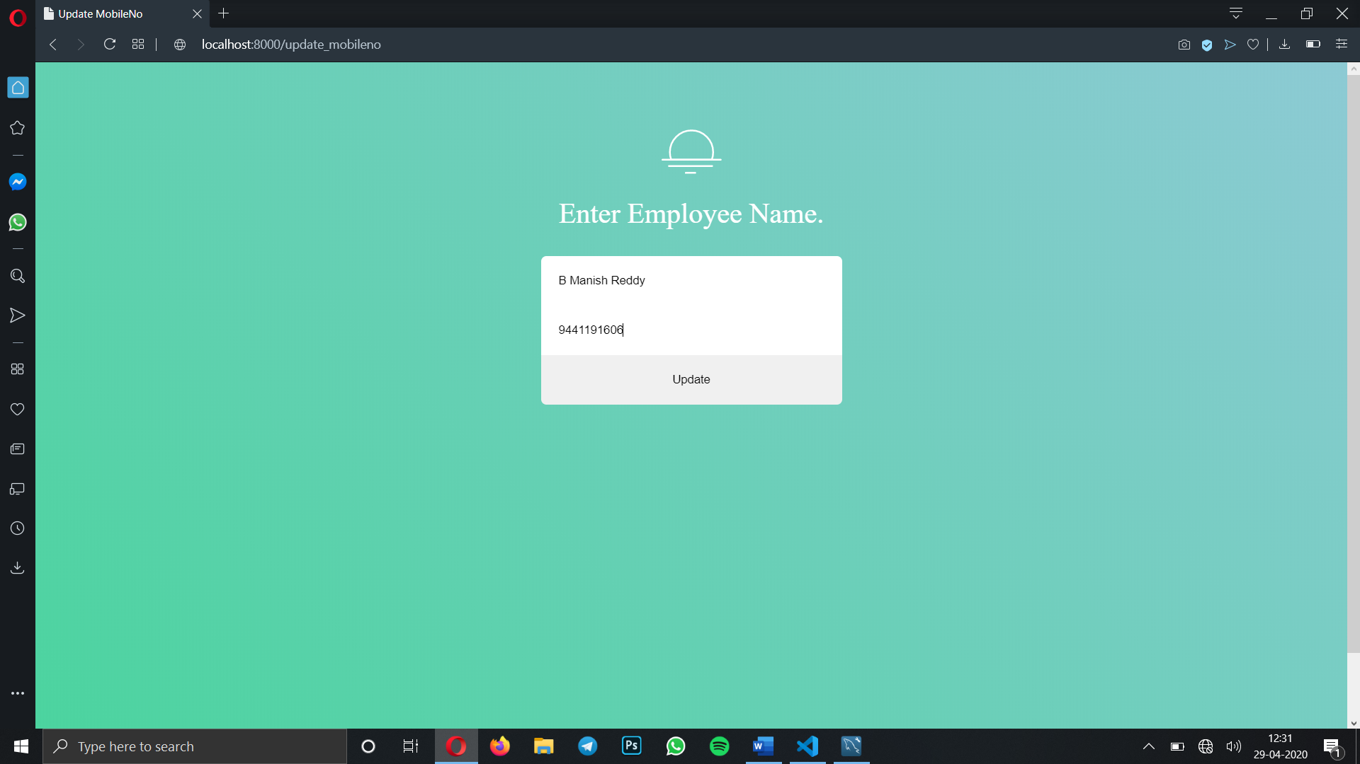

As you see after performing the update phone number the number of employee B Manish Reddy has been changed from 9600776713 to 9441191606.

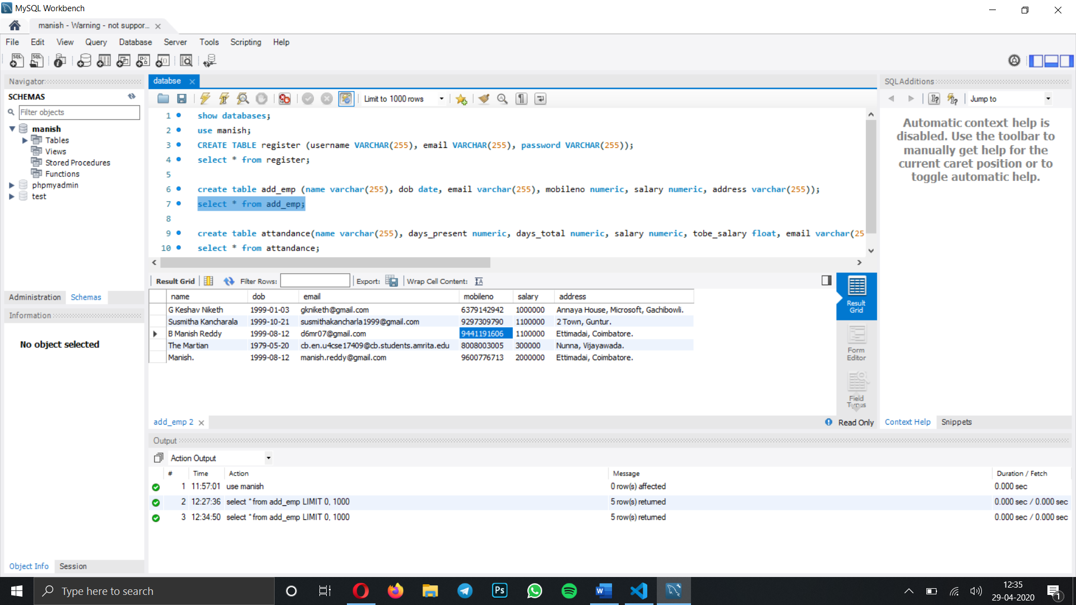

**Form 10** : Now we will move to update salary of employee B Manish Reddy from 11,00,000 to 10,00,000. Here in this form I choose employee name and salary to be updated.

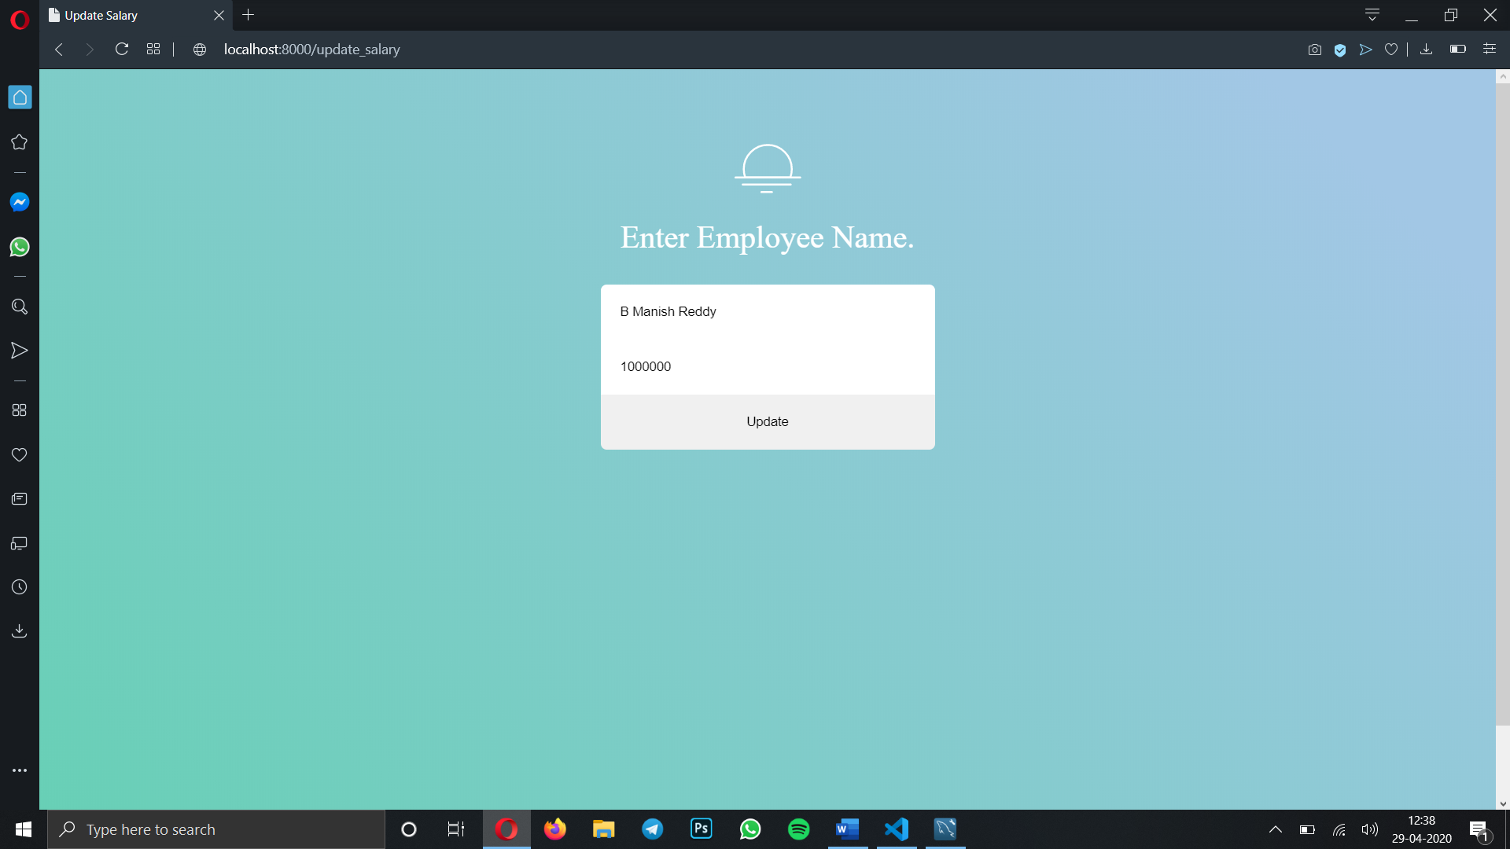

As you see after performing the update salary the salary of employee B Manish Reddy has been changed from 11,00,000 to 10,00,000. As shown in blue colour.

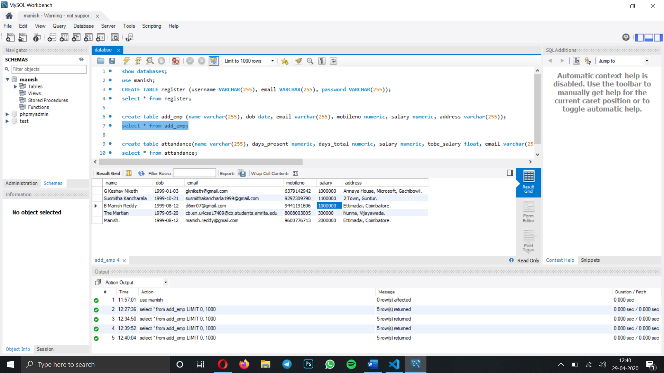

**Form 11** : Now we will move to update email of employee B Manish Reddy from d6mr07@gmail.com to manish.botta@outlook.com. Here in this form I choose employee name and salary to be updated.

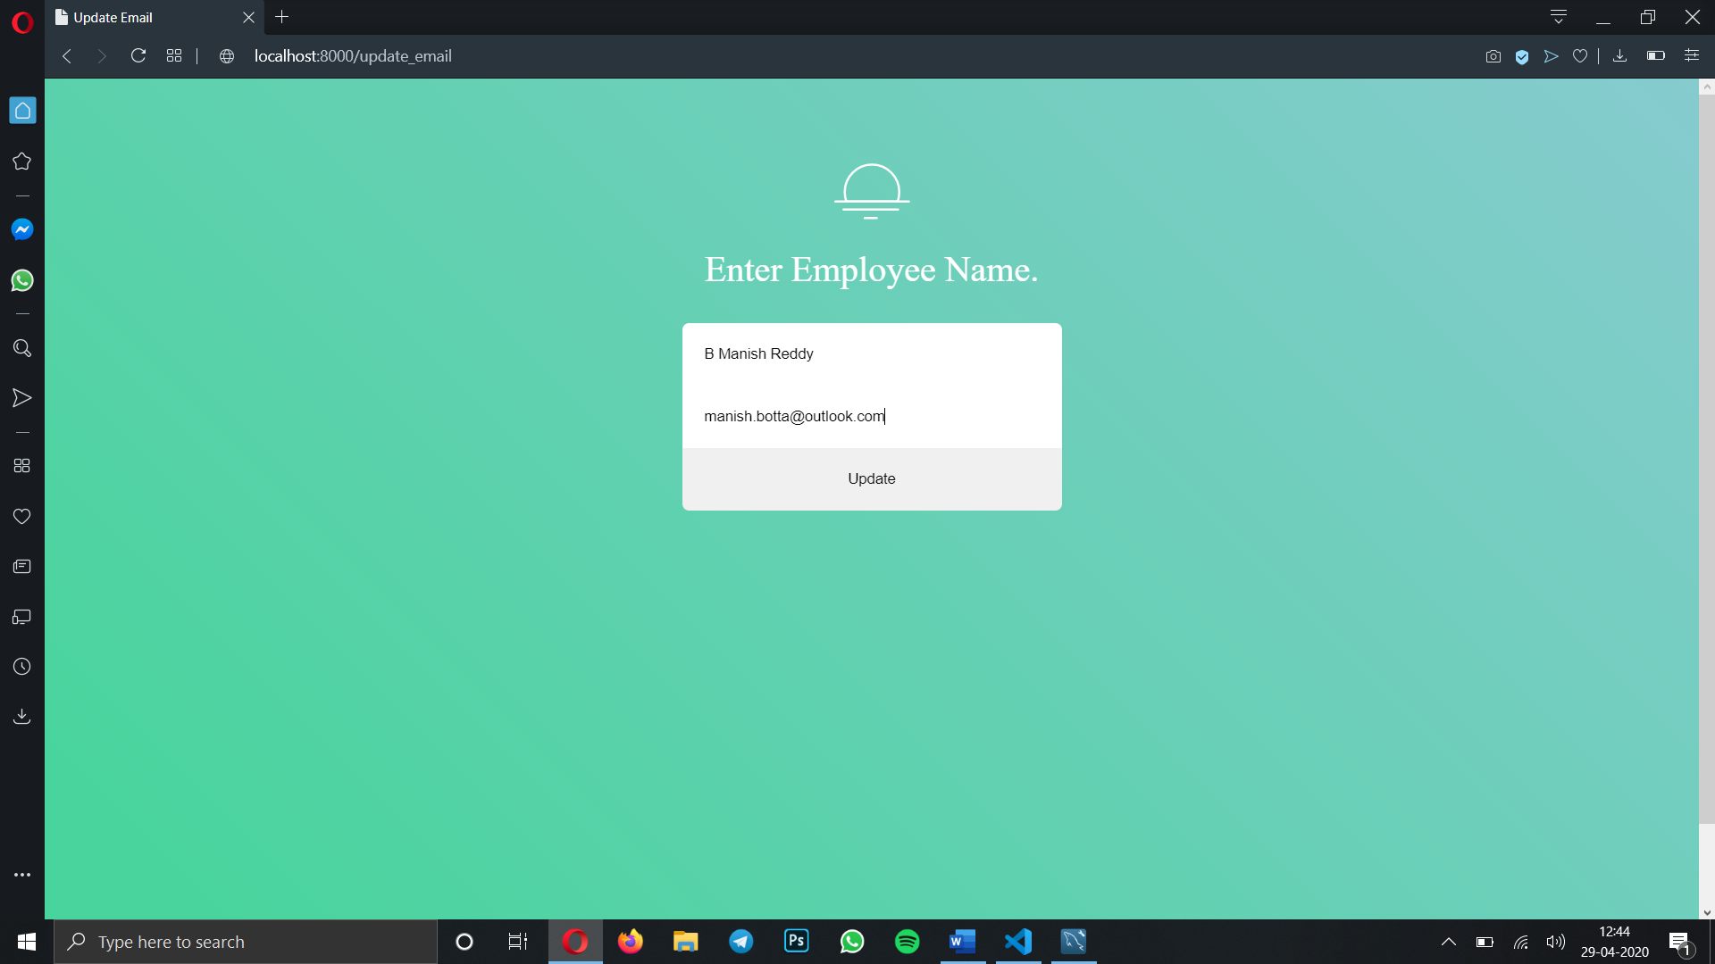

As you see after performing the update salary the salary of employee B Manish Reddy has been changed from d6mr07@gmail.com to manish.botta@outlook.com. As shown in blue colour.

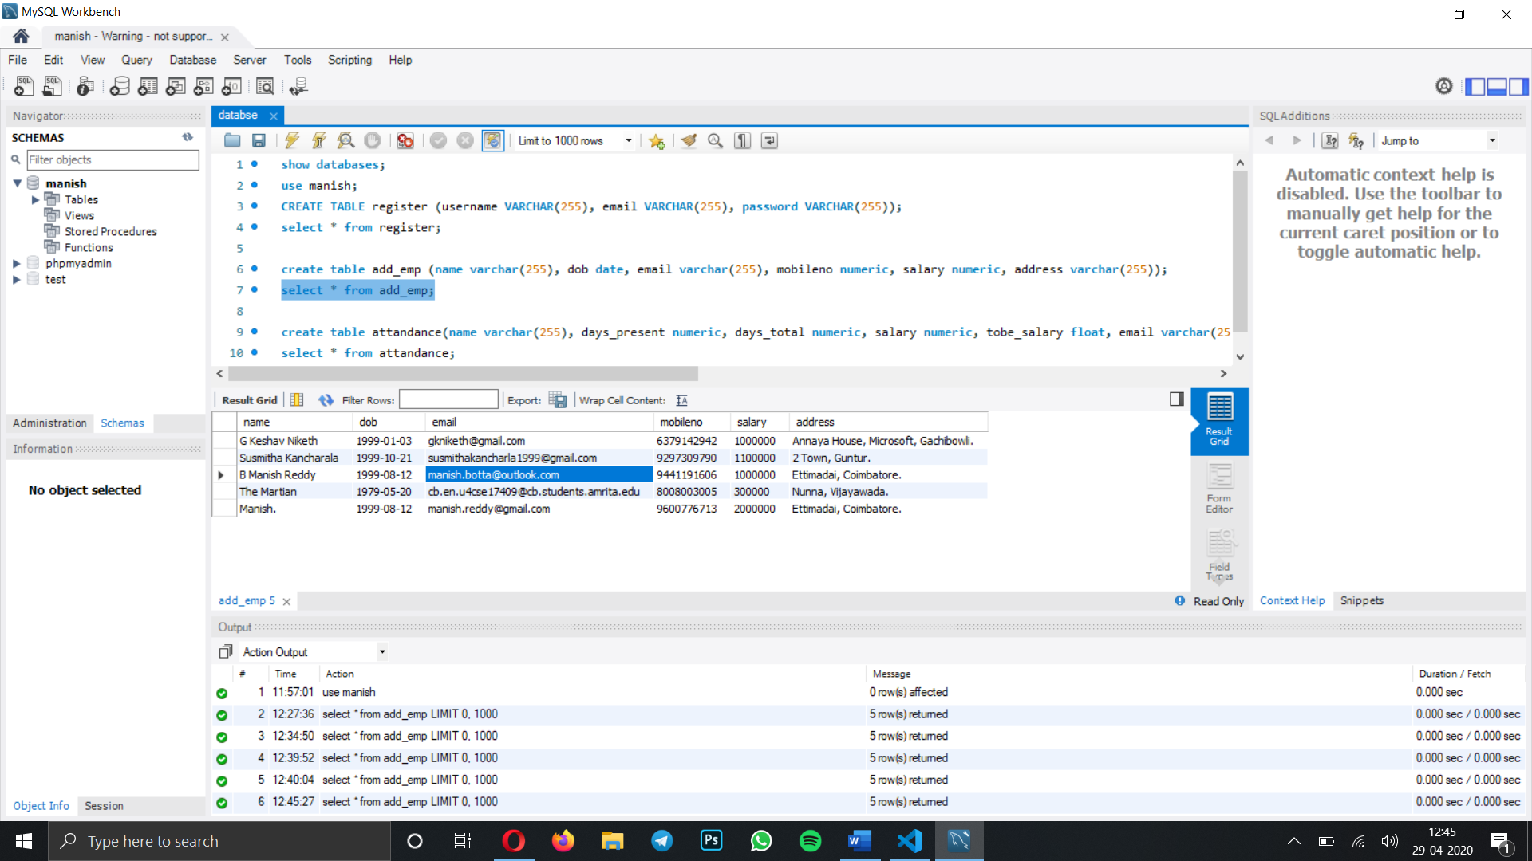

**Form 12** : Now we will move to update address of employee B Manish Reddy from Ettimadai, Coimbatore to Prodduturu, AP. Here in this form I choose employee name and salary to be updated.

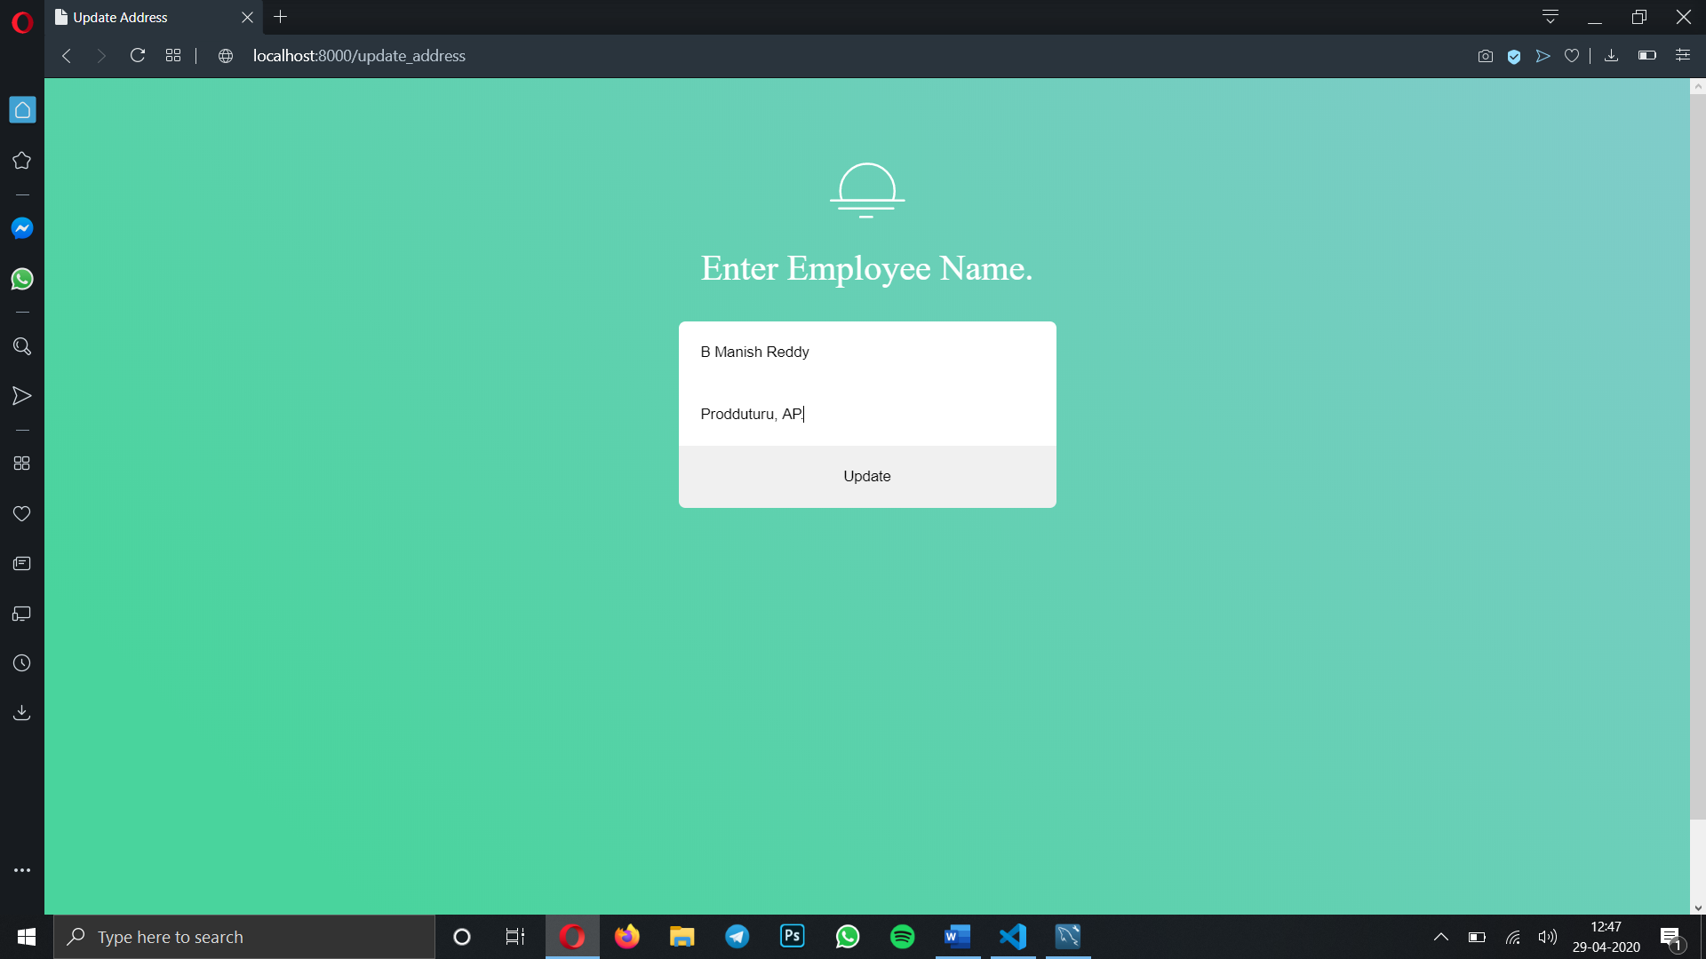

As you see after performing the update salary the salary of employee B Manish Reddy has been changed from Ettimadai, Coimbatore to Prodduturu, AP. As shown in blue colour.

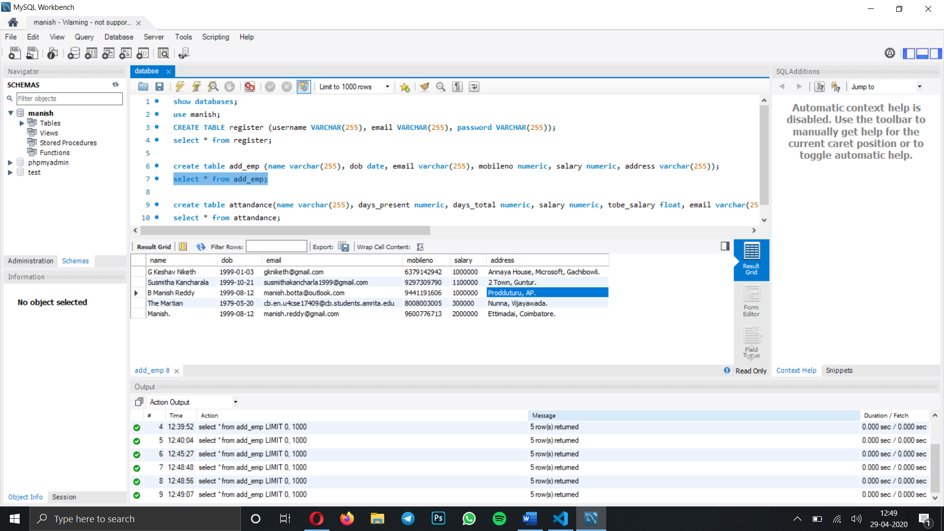

**Form 13** : Let’s move forward to next module deleting employee records from the database when a HR wants to terminate that employee. From the above database image in page 11 I want to delete employee with Name The Martian.

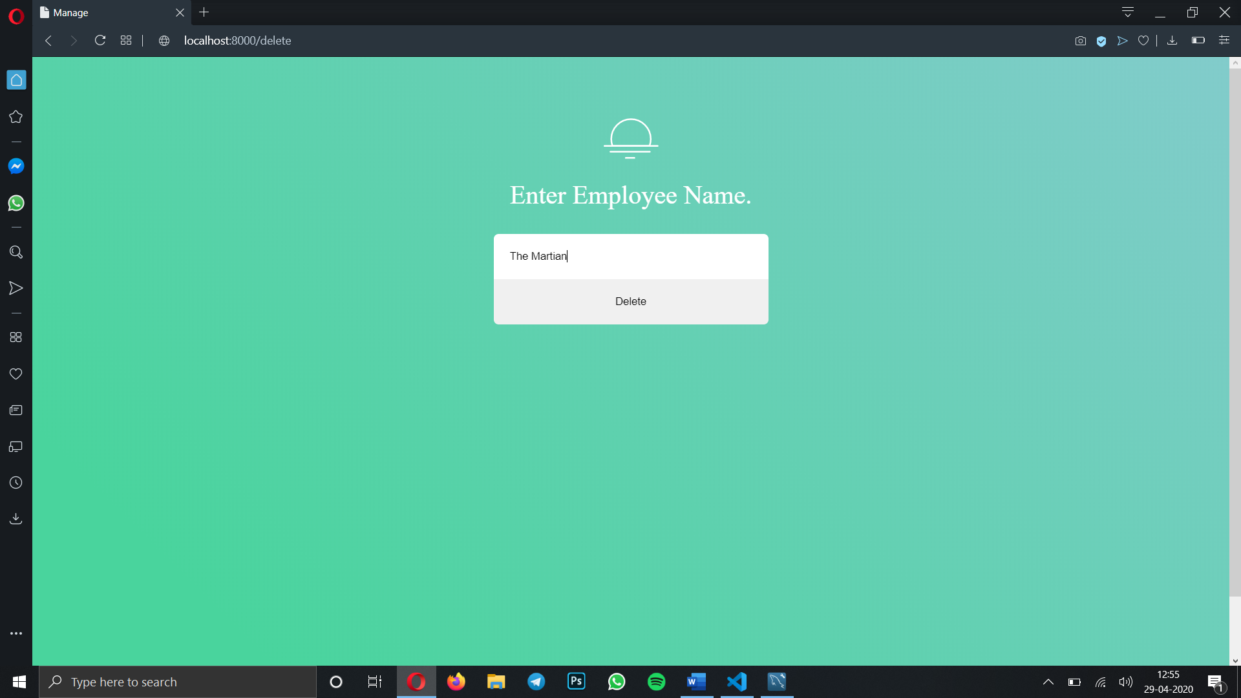

The employee with name The Martian has been deleted from the database.

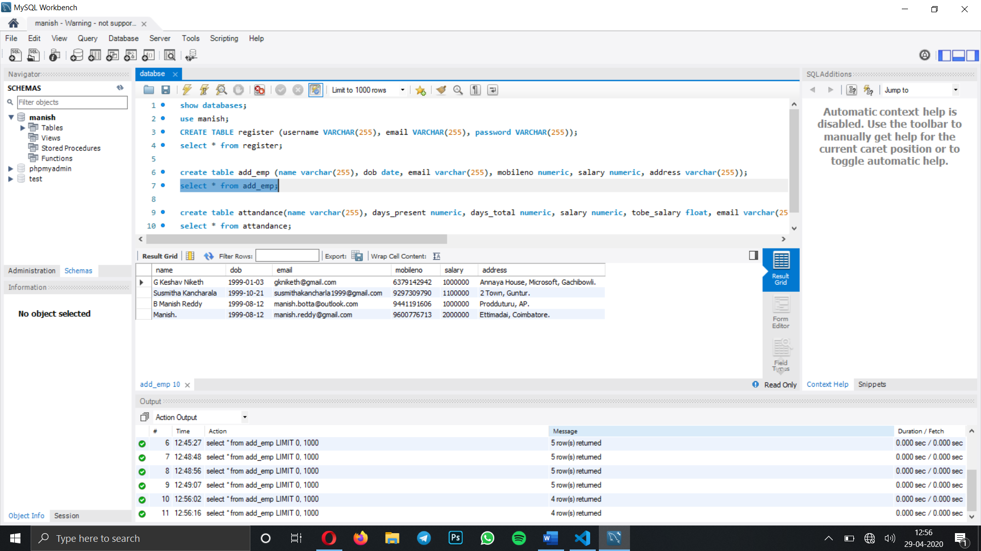

**Form 14** : Let’s go to final module sending emails to employee’s using the attendance sheet. We will send these employees salary to their mentioned email id’s.

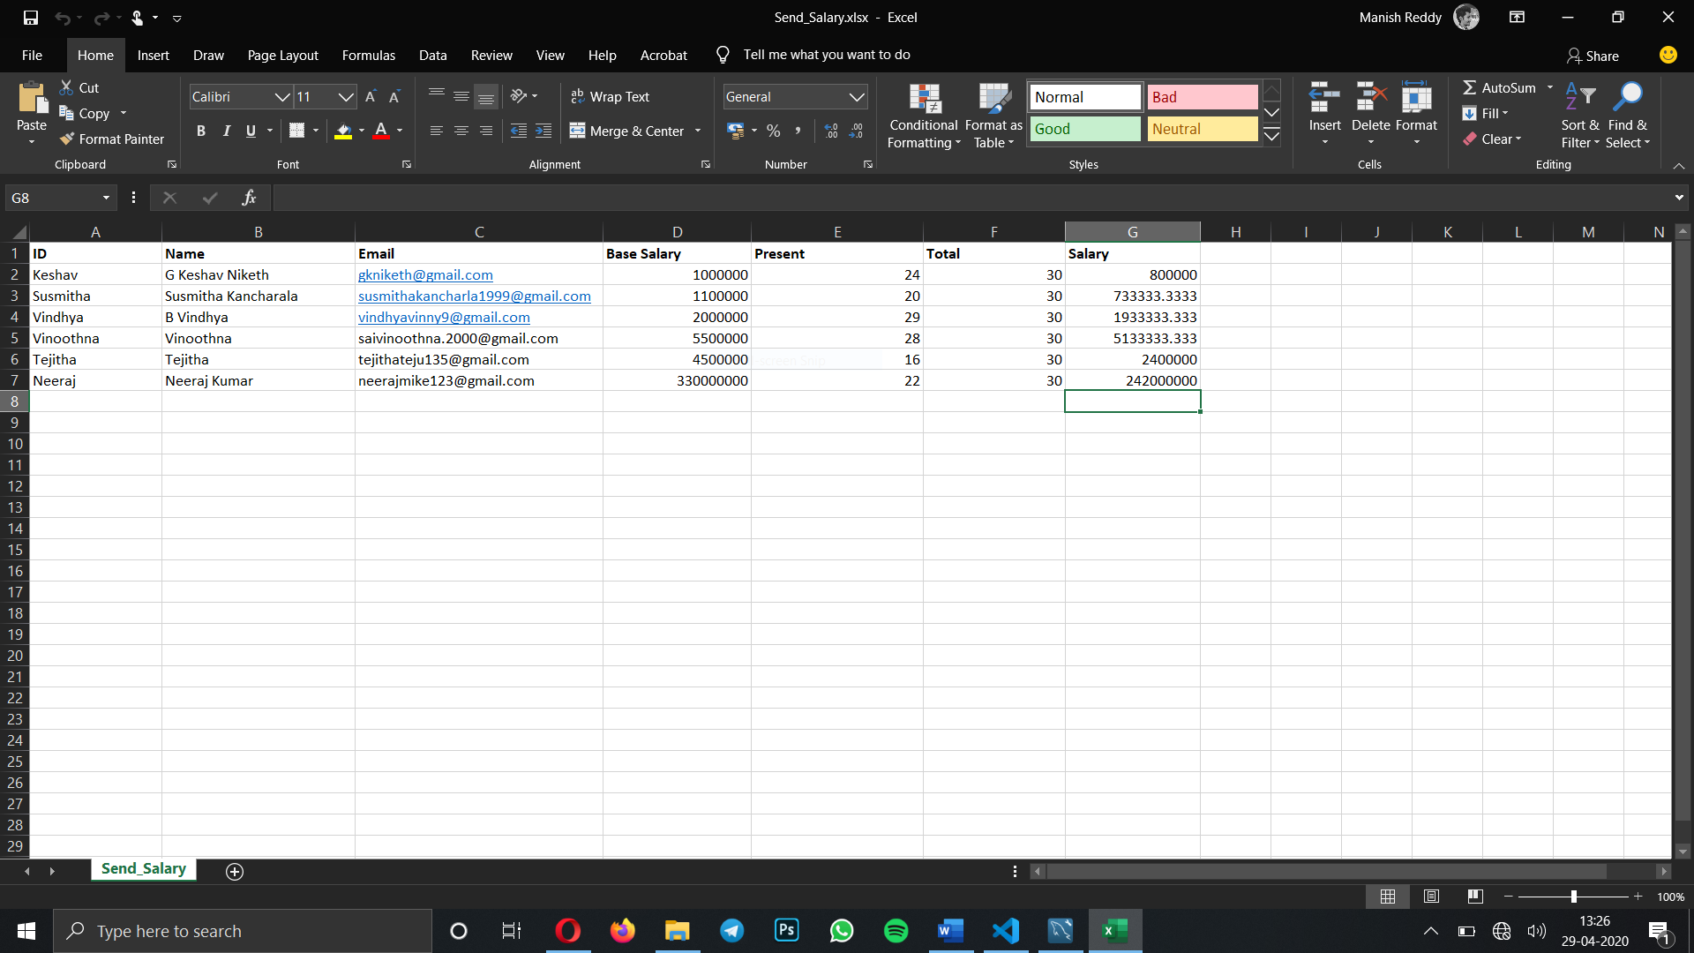

When you click send salary all the employees will receive their pay bill.

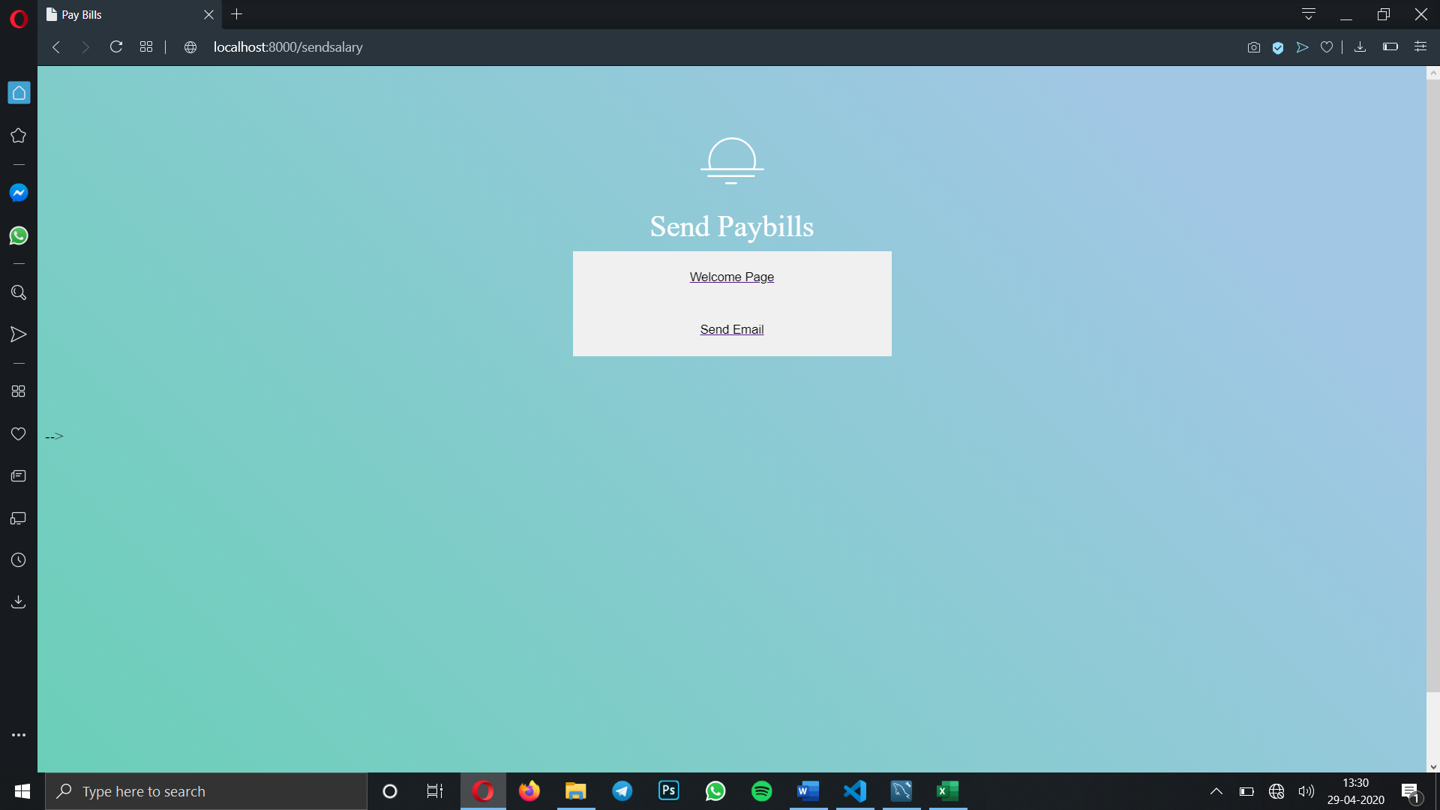

We can observe from the below screenshot terminal of visual studio code, the following employees received their mail. Intentionally I have stopped mail after sending to 3 persons. You can see their in terminal pay bills sent to Keshav sent to Susmitha sent to Vindhya.

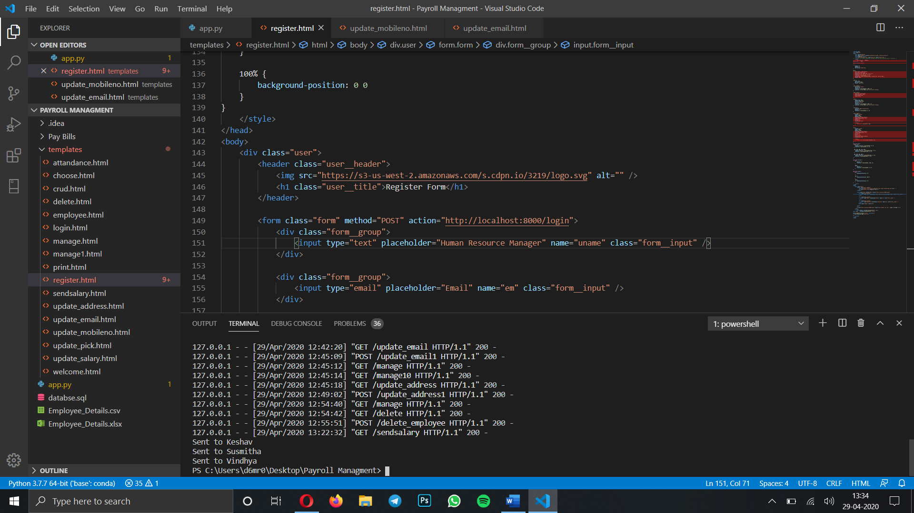

Here is the sent email from my mail account.

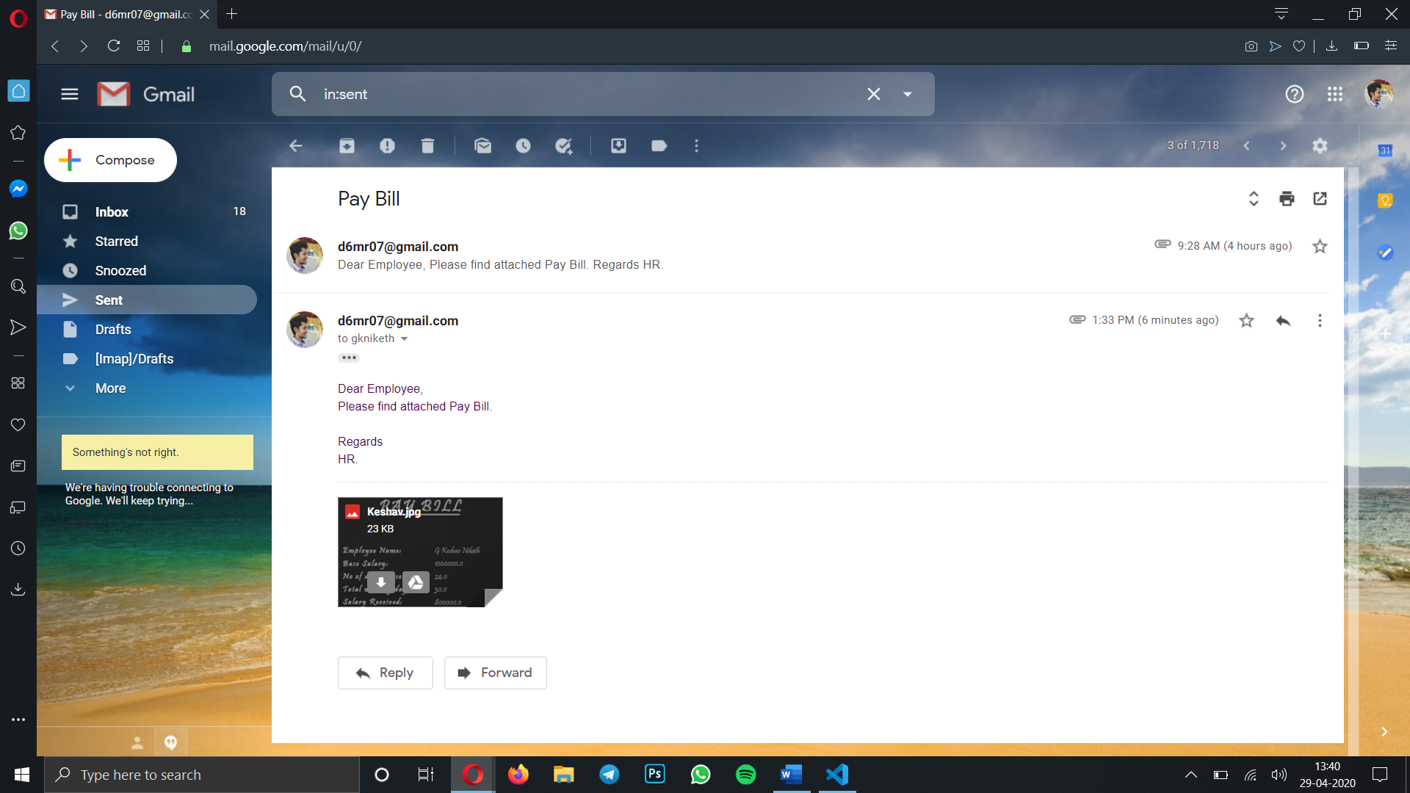

The pay bill is the form of an image

